In this project, you need to compare several different loans. The easiest way to do this is to use Sheets to calculate the quantities. However, you can’t simply type in the numbers as if you were filling out a table, you need to exploit the power of Sheets! By spending a little time linking the calculations, you can save yourself a lot of time when it comes to comparing loans.
For this technology, you’ll create a google Sheet to facilitate your calculations. Use the Sheets file p3_team? Shared with you by your instructor. This file is probably located on your Google Drive in the Shared with Me folder.
Much of the information to complete this assignment is in the project letter, your shared Google Sheet, or can be calculated by following the instructions in the handout.
- In cells A1 through A10, you will enter the names of several of the quantities for the property and loan. You’ll probably need to make the column wider by moving your cursor to the border between columns A and B at the top of the worksheet.
Drag the border by holding down the left mouse button.

Once you have widened column A, type in the entries you see below in column A. Your worksheet should look like the one below when you are done.
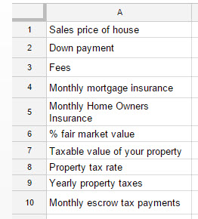
In cell B1, enter the sales price of the house.
- In cells B2 and B3, put appropriate down payment and fees for the loan you have chosen. To allow you to modify the sales price of the house and have the down payment calculated, type a formula like = 0.05*A1. In this particular case, the down payment would be 5% of the sales price.

- The cell B4 is the monthly mortgage insurance for the loan. Mortgage insurance is required for any loan where the down payment is less than 20% of the sales price. To get an estimate of the monthly cost of mortgage insurance, go to the mortgage insurance calculator at http://www.hsh.com/calc-pmionly.html .
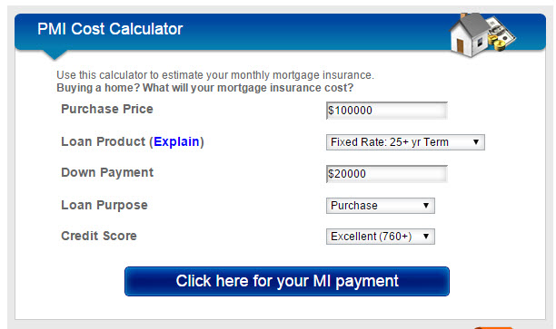
Enter the sales price, the proper fixed rate term, the down payment, and loan purpose. Assume your credit score is excellent and then select “Click here for your MI payment”. The monthly mortgage insurance will appear below the calculator.
Enter the monthly mortgage insurance payment in cell B4.

- Select cell B5. Put the monthly home owners insurance from the Project Letter in this cell.

- Click on cell B6. Type in 86% to indicate the fair market value percentage.

- In cell B7, we need to take the percentage in B6 and multiply it by sales price of the house in cell B1. So type = B6*B1. Press Enter to calculate the taxable value of the property.

- In cell B8, type the property tax rate from the Project Letter.

- In cell B9 we need to calculate the annual property taxes. This is done by using the taxable value of the property in cell B7. Since the taxes are assessed per $100 of taxable value, we need to divide the taxable value by 100 and then multiply by the property tax rate. This means that cell B9 should contain = B7/100*B8.

- The monthly escrow payment is added to your loan payment to cover taxes and insurance. The monthly escrow payment per month is the sum of the taxes divided by 12, monthly mortgage insurance and monthly home owners insurance. Type a formula in B10 that calculates this sum.

- To test your worksheet, change the values in B1 through B4 to match those below. Your worksheet is probably correct if the monthly escrow payment in B10 matches. For testing purposes, continue to use the values below. Once you are sure the entire worksheet is correct, you can change it to reflect your specific loan.
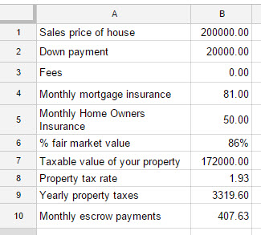
If your worksheet is linked properly, you should be able to change the sales price to 150000 and see your Monthly escrow payments change to 338.48.

- In cells A12 through A24, put the following entries for the loan.
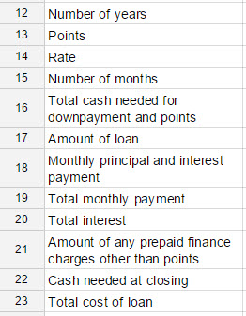

- In cells B12 though B14, enter the appropriate information from your loan. Follow any percents with a % symbol. If any of your numbers are rounded too much, click on the offending cell and press the button along the top of the sheets window. For testing purposes, you can use a term of 30, points as 1%, and the rate of 3.5%.

- In B15, enter a formula that calculates the Number of months in the loan using the value in B12.

- In cell B16, type a formula for the cash needed for points and down payment. To find this formula, use , where A is the amount of money needed for down payment and points, C is the sales price of the house in B1, and pts is the points in B13.

- In cell B17, type a formula for the amount of the loan using the sales price in B1 and the down payment in B2.
- In cell B18, use the formula to calculate the monthly principal and interest payment. Make sure you use the rate per period to calculate i. This is the most critical step. Make sure the number you get in Sheets matches the value calculated by hand.

- In cell B19, type a formula for the total monthly payment using the total monthly escrow payments in B10 and the monthly principal and interest in B19.

- In cell B20, calculate the total interest using the monthly principal and interest payment in B19, the number of months in B15, and the loan amount in B17.

- In cell B21, enter the amount of prepaid finance charges other than discount points for the loan or fees included in B3. These might be origination points (a fee charged by the lender to cover the costs of making the loan).

- In cell B22, enter the cash needed at closing using fees (B3), cash needed for down payment and points (B16), and cash needed for prepaid finance charges (B21).

- Finally, enter a formula in B23 for the total cost of the loan using any points paid, any fees paid, and the total interest in B20.

- If your worksheet contains the proper formula, it should look like the one below. Remember that the one below contains test data. To complete the project, you will need to use your specific information and loan details.
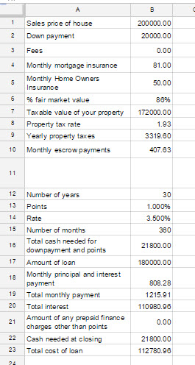
Now change the values in the worksheet to match the project assigned to you. Vary the sales price to get the total monthly payment as close to the maximum amount Penny can afford per month.

- Make sure the tab you put this information and calculation in contains your last name. Just to be safe, you should also put your name in the sheet itself in cell E1.

