In Project 1, you modeled college costs with a linear function 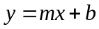. You did this by calculating the slope m and the y intercept b using two of the data points assigned to you. There is an alternative way to do this that utilizes matrices. This strategy is very important since you can apply it to find the equation of a quadratic function that passes through three of your data points. In this assignment, you’ll focus on finding the same lines you found in Project 1, but using matrices.
Let’s see how this works by finding the equation of a line that passes through the two data points 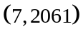and 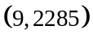. These are two of the data points from the US data for college costs at two year colleges. You will use the points for two year colleges you used in Project 1 when you apply this strategy in this Tech Assignment.
Start by substituting each ordered pair into . For the two points above, we get
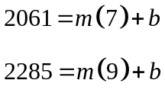
Although the variables are not the usual x and y, this is a system of two linear equations in two variables. To see this reorganize the equations to give
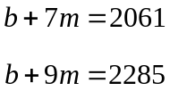
The augmented matrix for this system is
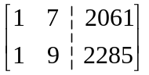
In this matrix, the entries in the first column are the coefficients on b and the entries in the second column are the coefficients on m. Our goal is to document the row operations needed to convert this matrix into reduced row echelon form (RREF).
The entry in the first row, first column is a 1 so we do not need to modify it to get RREF. However, we do need to use row operations to fill the rest of that column with zeros. Multiply the first row by -1 and add it to the second row. Place the result in the second row.

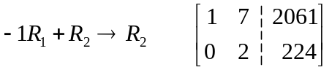
Now we need to make the entry in the second row, second column into a 1. To do this, divide the second row by 2 and place the result in the second row.
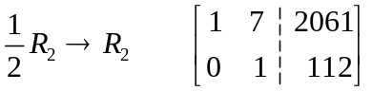
Finally, multiply the second row by -7 and add it to the first row. Place the result in the first row to make the entry in the first row, second column a 0.
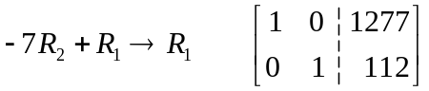
This is reduced row echelon form and it means that
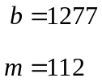
which makes the equation of the line through the two points
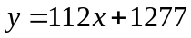
This matches the equation found in a Technology Assignment for Project 1.
To complete this technology assignment, you need to carry this strategy out for the two points from your two year college data you used in Project 1. Your goal is to document the steps in a Word document like the one on the next page. To be able to do this, you will need to use the equation editor in Word to make equations, matrices, and subscripts. Directions for doing this follow the sample below.
For this technology assignment, you will turn in a document that includes the information in the box below. Your goal is to end up with the same equation you found for two year college costs in Project 1. This means you need to use the points you used in Project 1. Your row operations will be slightly different, but should have the same format as those below.

Your Name Here
MAT 152

Find the Equation of a Line Through Two Points Using Matrices
Start with the points (7, 2061) and (9, 2285). Put these into to give
This gives the system of equations
The augmented matrix is
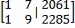
Now put into reduced row echelon form:
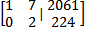
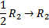
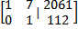
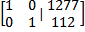
The reduced row echelon form corresponds to
So the equation of the line is .

Create Inline Equations and Display Equations
Equations that appear within a sentence are called inline equations. Equations that appear on a line by themselves are called display equations. You can easily switch between an inline equation and display equation.
- We’ll start by creating an inline equation. Type the sentence you want to place the equation. When you get to the point where you want to place the equation, click on the Insert tab. On the far right of the buttons along the top, click on the Equation button. | 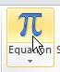
- An equation region is created at the insertion point in the sentence. | 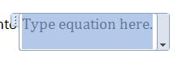
- Click inside the equation region and type your equation. Once the equation is complete, click outside the region to continue typing the sentence. | 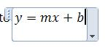
- Now let’s create a display equation. Under the Insert tab, click on the Equation button again.
- Type in the equation. Select the button on the right side of the equation region to reveal a menu. Select Change to Display to move the equation to its own line. | 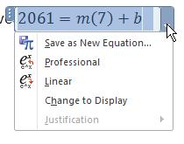
- To insert another equation under the previous equation place the insertion point at the end of the previous equation. Press SHIFT and ENTER at the same time to go to a new line. | 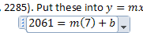
- Now you can click on the Equation button and type in the second equation under the first one. | 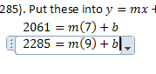

Create a Matrix
You will also need to create matrices in your document. This can also be done using the equation editor in Word.
- Place the insertion point where you want to put the matrix. On the Insert tab, select Equation. Make sure the insertion point is inside the equation region.
- The matrix starts with a set of square brackets. You can find these brackets under the Bracket button. | 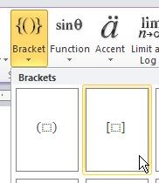
- Place the insertion point inside of the brackets. | 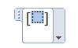
- Click on the Matrix button and select a 2 x 2 matrix. | 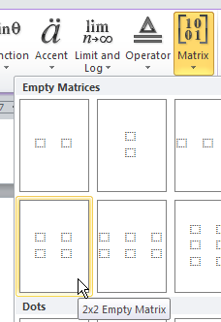
- Move the insertion point between the last column of the matrix and the right bracket. | 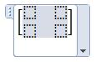
- From the keyboard, type a vertical bar. | 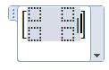
- Now we want to add a 2 x 1 matrix between the vertical bar and the right bracket. To do this, click on the Matrix button and select the 2 x 1 matrix. | 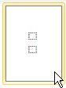
- Your 2 x 3 matrix should now look like the one to the right. | 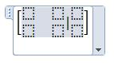
- Enter the numbers into the matrix. You can create later matrices in the document by copying this equation and pasting it where you need. Then change the entries. | 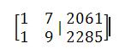

Create Row Operation Instructions
The instructions for row operations include subscripts, arrows and fractions. The instructions below show how to create these elements.
- To start the equation, click on the Equation button on the Insert tab.
- In the equation region, start typing your row operation. | 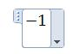
- When you get to the point where you want to type R with a subscript to denote one of the rows in the matrix, click on Script under Equation Tools. In the first row you’ll find a placeholder for subscripts. Click on that button. | 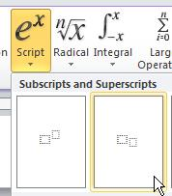
- This will put the placeholder in your equation. | 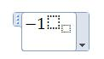
- Put the insertion point in the placeholder. | 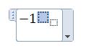
- Type R and the move the insertion point to the subscript and type a number for the row in the matrix. | 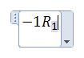
- Type a plus and then repeat steps 3 through 6 to show which row you are adding to. The instructions to the right indicate that you multiply the first row by -1 and add it to the second row. In the next steps we’ll add information to indicate where the sum will be placed in the new matrix. | 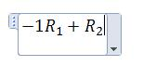
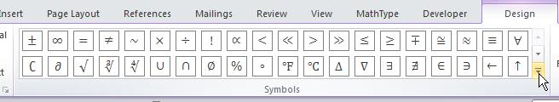
- On the left side of the Equation Tools is a palette of different symbols you can put into your equation region. If you scroll down, you will find a right arrow.
- Click on the right arrow to insert it into your equation region. | 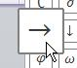
- Repeat steps 3 through 6 to finish your row operations. It may be easier to copy this row operation and paste it later to use as a starting point for other row operations. | 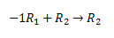
- You can also create fractions by pressing the Fraction button under Equation Tools. | 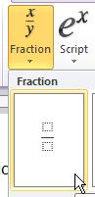
- Once you have the fraction started, place the insertion point in the numerator and denominator and type the appropriate numbers. | 

