- A random experiment consists of drawing a single card from a well shuffled deck and recording the suit. Write a sample space for this experiment. You can use abbreviations.

- Four children, Mary, Nancy, Owen, and Penelope get in line in random order to go out to recess. The order in which they line up is observed and recorded as a string of letters ABCD. Express the ways they can line up as a systematic list.

- Suppose you want to create a computer password that has to be 10 digits long with each digit being chosen from the numbers 0through 9. How many different passwords are available if the numbers can be repeated?

- A lottery game consists of picking five numbers between 1 and 36 inclusive. You want to buy a ticket with the numbers 1, 2, 3, 4, and 5. You friend laughs at you and says that those five numbers are really unlikely. What should you say to your friend to explain why he is right or wrong?

- The new iPhone comes in five different colors. There are three different sizes of memory available. The store has a selection of ten different cases to fit it. Assuming a person wants to buy an iPhone and a case, how many different phone/case combinations are possible?

- Ten runners participate in the 100 meter hurdles. In how many ways can the medals for the top three finishers be awarded?

- In how many ways can a five-card poker hand be drawn from a standard deck of cards?

- Three friends, Al, Ted, and Bert run a foot race with five other boys. What is the probability that: Ted finishes first, Bert finishes second, and Al finishes third? The three friends all finish in the top three places?

- Stanley wants to rearrange six science books and four history books on his shelf. How many arrangements are possible if: the books can be in any order? The science books are on the left and the history books are on the right? The four history books are in the middle and with three science books on each end.

- Two fair dice are tossed and the sum is recorded. What is the probability that you get a total of 8 or a total of 12?

- Two fair dice are tossed and the sum is recorded. What are the odds in favor of getting a total of 9?

- A single card is drawn from a deck of 52. What are the odds that you draw a 9?

- The odds that a randomly selected student is male are 21 to 25. Find the probability that a randomly selected student is a male.

- A bowl contains 10 red balls, 15 white balls, and 20 black balls. A single ball is selected at random. What is the probability that the ball is:
- Red?
- White?
- Not black?
- Black or white?

- Three fair coins are tossed at the same time. What is the probability of getting exactly two heads? Hint, use the sample space you made for 3 coins.

- A single die is rolled. What is the probability of not rolling a 5?

- Suppose you roll a single fair die. What is the probability of getting a two or an even?

- Suppose you draw a single card from a deck. What are the probability that you draw the Ace of Spades or a 9?

- A student observes 46 vehicles in the YC parking lot. He notices that 12 of the vehicles are red and that 19 of the vehicles are 4-wheel drive. If the probability that a randomly chosen vehicle in the YC lot is red or has 4 wheel drive is 0.609, what is the probability that the car is red and has 4 wheel drive?

- A mother figures that her son will forget his homework about 20% of the time. What is the probability that he will forget his homework at least once in the next 10 school days?

- A teacher looks over her class and notices a few trends. Out of the 60 students in the class, 23 have brown hair, seven have green eyes, and three have both brown hair and green eyes. What is the probability that randomly selected student has either brown hair or green eyes?

- Suppose you draw two cards from a standard deck of cards without replacement. What is the probability:
- You draw an Ace on the first card and a seven on the second card?
- You draw a heart on the first card and a spade on the second card?
- You draw a 8 on the first card and a face card on the second card?
- You draw two hearts in a row?

Use the table for #23
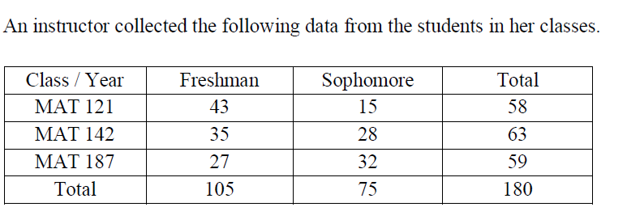
- Use the data in the table to compute the probability that a randomly selected student:
- is a freshman and taking MAT 142?
- is a freshman or taking MAT 142?
- is a freshman given they are taking MAT 142?

- A single card is drawn from a well-shuffled deck of 52 cards. If the card is an ace, you win $12; otherwise you lose $1.50.
- What is the expected value of the game?
- Explain what the expected value means.
- Is this a fair game or not?

- Four thousand tickets are sold at $1 each for a charity raffle. Tickets are drawn at random. There is one $800 first prize, two $300 second prizes and eight $50 third prizes.
- What is the expected value of this raffle if you buy one ticket?
- Is this a fair game? If not fair, what would they need to charge per ticket to make it fair?

