# Section 4.1 Linear Equations

* How do you solve a linear equation?
* How can intercepts be used to graph linear equations?

## How do you solve a linear equation?

Key Terms

Linear Growth Linear Equation in Two Variables

Summary

This chapter is about growth, and how to model growth with equations. We will be investigating linear growth, quadratic growth, and exponential growth.

Typically, we measure a quantity with respect to time, so **linear growth** **refers to a quantity that changes at a constant rate for each unit of time**. For example, let’s say you graduate college and get a job that pays $1500 a week (after taxes, benefits, etc). You could model this scenario with the equation where *y* is the amount of money you earn after *x* weeks of working. Notice the growth rate is 1500 per week, and it stays the same each week.

The equation above is an example of a **linear equation in two variables: an equation that can be written in the form , where *A, B,* and *C* are real numbers (*A* and *B* can’t both be zero)**. Later we will investigate quadratic equations that are characterized by having an  term, and then exponential equations that are characterized by having a  term.

When solving linear equations, keep these two important algebraic properties in mind:

1. You can add or subtract a quantity on both sides of an equation.
2. You can multiply or divide by a nonzero quantity on both sides of an equation.

Notes

Guided Example 1 Practice

|  |  |
| --- | --- |
| Recall our job scenario above and suppose that that you had saved $3000 in your checking account before you started the job, and your paycheck is directly deposited each week. You could model this scenario with the equation  where *y* is the amount of money in your checking account after *x* weeks of work.  Use this equation to figure out how many weeks of work it would take you to have $12,000 in your checking account.  **Solution** Since *y* represents the amount of money in the checking account, we substitute 12,000 for *y* and then solve for *x*.  Substitute 12000 for y.  Subtract 3000 from both sides.  Divide both sides by 1500.    So it will take **6 weeks** of work to have $12,000 in your checking account. | Suppose you run a small carpentry business, and you currently have 15 cabinets in your inventory, and can produce 5 new cabinets per week. You could model this scenario with the equation , where *y* is the number of cabinets you have available for installation in *x* weeks.  If the local high school needs 45 cabinets for their new art building, how many weeks would it take to fill that order? |

Guided Example 2 Practice

|  |  |
| --- | --- |
| Solve  for *y*.  **Solution** Isolate *y* by carrying out the steps below.    Subtract 8*x* from both sides  Divide both sides by 4  Divide each term by 4  Notice our result is also a linear equation in two variables, and it is equivalent to the equation we started with. By solving for *y* we have simply rearranged the terms in the equation. | Solve  for *a*. |

## How can intercepts be used to graph linear equations?

Key Terms

*x*-intercept *y*-intercept

Summary

The graph of a linear equation in two variables is a straight line, and the points where a line crosses the *x* and *y* axes are called intercepts. The ***x*-intercept of a line is the point where the line crosses the *x*-axis**. You can **solve for an *x*-intercept by setting *y* equal to zero and solving for *x***. This is because any point on the *x*-axis must have a *y*-coordinate of zero.

Similarly, the ***y*-intercept of a line is the point where the line crosses the *y*-axis**. You can s**olve for a *y*-intercept by setting the *x*-coordinate equal to zero and solving for *y***.

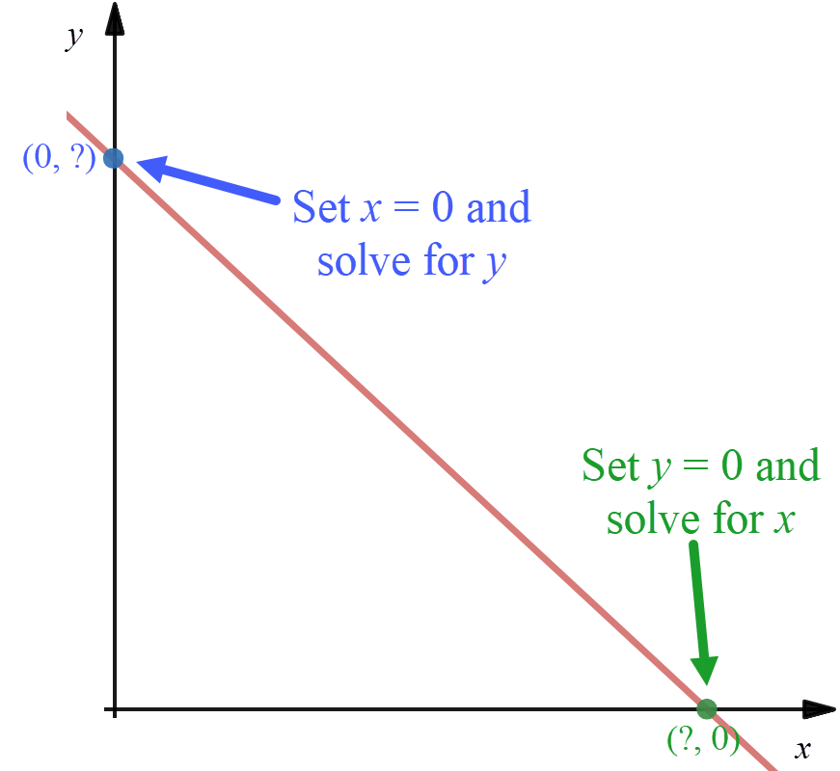

All straight lines have both an *x*-intercept and *y*-intercept, except horizontal and vertical lines which only have one or the other.

You need at least two points in order to graph a line, so once you have the intercepts, you can easily plot these and sketch the line that passes between them.

Notes

Guided Example 3 Practice

|  |  |
| --- | --- |
| Find the *x* and *y* intercepts of the line given by the equation  and use them to sketch a graph of the line.  **Solution**  *x*-intercept: Set *y* to zero and solve for *x*.  Set *y* equal to 0  Simplify  Divide both sides by -3    So, the *x*-intercept is (-2, 0).  y-intercept: Set *x* to zero and solve for *y*.  Set *x* equal to 0  Simplify  Divide both sides by 2    So, the *y*-intercept is (0, 3).  Next, we will plot these points, and sketch the line that passes between them. | Find the *x* and *y* intercepts of the line given by the equation  and use them to sketch a graph of the line. |

Guided Example 4 Practice

|  |  |
| --- | --- |
| Suppose you are hired to mow the lawn at a local park. If the park has 5 acres of grass, and it takes you an hour to mow half an acre on a riding lawn mower, you can model this scenario with the equation where *y* is the number of acres left to mow after *x* hours. Find the *x* and *y* intercepts of this equation, interpret their meaning, and use them to sketch a graph of the linear model.  **Solution**  *x*-intercept: Set *y* to zero and solve for *x*.  Set *y* equal to 0  Add  to both sides  Multiply both sides by 2    So, the *x*-intercept is (10, 0). In context this means after 10 hours of mowing, you have 0 acres left to mow, meaning it takes you 10 hours to complete the job.  *y*-intercept: Set *x* to zero and solve for *y*.    So, the *y*-intercept is (0, 5). In context this means after 0 hours of mowing, you still have 5 acres left to mow, meaning at the start of the job there are 5 acres to mow.  Next, we will plot these points, and sketch the line that passes between them. | Suppose you need to drain your swimming pool, and you use a pump that can remove 500 gallons per hour. You can model this scenario with the equation  where *y* is the number of gallons left in the pool after *x* hours of pumping. Find the *x* and *y* intercepts of this equation, interpret their meaning, and use them to sketch a graph of the linear model. |

# Section 4.2 Modeling with Linear Equations

* How can you use a point and slope to build a linear model?
* How can you use two points to build a linear model?

## How can you use a point and slope to build a linear model?

Key Terms

Slope Slope-Intercept Form

Summary

The **slope of a line** **represents the rate of change of that line**, that is, the rate at which the dependent variable (*y*) is increasing or decreasing as the independent variable (*x*) increases. An increasing quantity is represented by a positive slope, and a decreasing quantity is represented by a negative slope.

The equation of a line can be written in several forms, but probably the most useful and common form is the slope-intercept form:

**Slope-Intercept Form**: If a line has a slope *m*, and a *y*-intercept *b*, then its equation in slope-intercept form is



It is often useful when working with a linear model in this form to think of *m* as the rate of change of the quantity, and *b* as the fixed or initial value of the quantity.

Recall in a previous example we used the model  where *y* was the number of acres left to mow after *x* hours. Notice this equation is in the form  where *m* is  and *b* is 5. This means there were initially 5 acres to mow, and the number of acres left to mow was decreasing at a rate of half an acre per hour.

Given a general point and the slope, you must first solve for the y-intercept, *b*, before you can write the equation in slope-intercept form. To do this, you can use the *x*-coordinate, *y*-coordinate, and slope *m* to solve for *b* as illustrated below.

Notes

Guided Example 1 Practice

|  |  |
| --- | --- |
| Find a linear equation of the line with slope 2 passing through the point (-1,4).  **Solution**  Given a slope of 2, an *x*-coordinate of -1 and a *y*-coordinate of 4, we can substitute these values into the slope-intercept form  and solve for *b*.  Substitute values for *x*, *y*, and *m*  Simplify  Add 2 to both sides    Now that we have *m* and *b* we can write the equation in slope-intercept form:    . | Find a linear equation of the line with slope -5 passing through the point (1,1). |

Guided Example 2 Practice

|  |  |
| --- | --- |
| In 2017 a company reported a revenue of $20.15 million, and it had increased at a rate of $1.2 million per year. Use this information to create a linear model and predict the company’s revenue in 2025.  **Solution** We will define *x* to be the number of years after 2017, and *y* to be the company’s revenue in millions of dollars. Since the revenue was $20.15 million in the year 2017, we can write that as the point (0, 20.15). The revenue is increasing by a rate of $1.2 million per year so the slope *m* is 1.2. Notice by defining *x* in this way, 20.15 is our initial value or *y*-intercept, so we already know that *b* is 20.15. Now we write our equation in slope-intercept form:    To predict the revenue is 2025, first we need to note that 2025 is 8 years after 2017, so we will substitute 8 into the equation for *x*, and solve for *y*:  Substitute 8 for *x*  Simplify    According to our model, in the year 2025 the company’s revenue will be $29.75 million. | In 2016 the average student loan debt per borrower was $32,731 and was increasing by $6,546.20 each year. Use this information to create a linear model and predict the year when the average debt will reach $50,000. |

## How can you use two points to build a linear model?

Key Terms

Slope Formula

Summary

Instead of being given a point and a slope, sometimes we are only given two points with which to construct our model. Our first task in that situation is to calculate the slope of the line that passes through those points. On the *xy*-plane, we define slope as the change in *y* over the change in *x*, and we get the following formula:

**Slope Formula**: If a line passes through two points  and  we can calculate the slope, *m*, of that line using the formula:



Given two points, we can use the slope formula to find the rate of change of the quantity. Then we can proceed in constructing our model by using a point and the slope to solve for *b*, or we can define *x* in such a way as to use a point as our initial value, as seen in the previous exercises.

Notes

Guided Example 3 Practice

|  |  |
| --- | --- |
| Find the equation of the line passing through the points (2, 4) and (-1, 5).  **Solution** We will use the point (2,4) as  and (-1, 5) as  and substitute into the slope formula  :    Next, we can choose either point and use the slope to solve for *b* as we did in the previous examples. We will use the first point (2, 4) for *x* and *y* and  for the slope *m* in the slope-intercept form :  Substitute values for x, y, and m  Simplify  Add  to both sides    The equation in slope-intercept form is:    . | Find the equation of the line passing through the points (-3,1) and (6, -7). |

Guided Example 4 Practice

|  |  |
| --- | --- |
| Suppose the average starting salary for a bachelor’s degree recipient in the US was $45,473 in 2014, and in 2018 it increased to $50,390. Model this information with a linear equation and predict the year when the average starting salary will reach $65,000.  **Solution** We are given two salaries with their corresponding years, and if we define *x* as the number of years after 2014 and *y* as the salaries, then we can write $45,473 in 2014 as the point (0, 45473) and $50,390 in 2018 as the point (4, 50,390).  Next, we use these two points in the slope formula :    Our slope is 1,229 and the *y*-intercept is 45,473. This gives us the model . To predict the year when the average salary will reach $65,000, we will substitute 65,000 into the equation for *y* and solve for *x*:  Substitute 65000 for x  Subtract 45473 from both sides  Divide both sides by 1229    Since we defined *x* as the number of years 2014, an *x* value of 16 corresponds to the year 2030. So according to our model, the average salary will reach $65,000 in approximately the year 2030. | Suppose there were 117 thousand computer programming jobs in 2010 and that number increased to 295 thousand in 2017. Model this information with a linear equation and predict the year the number of computer programming jobs will reach 500,000. |

# Section 4.3 Modeling with Quadratic Equations

* What is the quadratic formula?
* How do you graph a quadratic equation?
* How can you model data with a quadratic equation?

## What is the quadratic formula?

Key Terms

Quadratic Equation Quadratic Formula

Summary

Linear equations are convenient and easy to work with, but not all growth is linear. Our next type of growth is quadratic growth. We begin with an overview of basic characteristics and techniques of quadratic equations.

**A quadratic equation is an equation of the form  .** Notice the highest power of *x* is , which means you can have up to two solutions to a quadratic equation. To solve quadratic equations, we use the quadratic formula:

**Quadratic Formula**: The solution to an equation of the form  (where *a* is not zero) is given by the formula,



Notice the equation must be set equal to zero before the formula is valid.

Notes

Guided Example 1 Practice

|  |  |
| --- | --- |
| Solve the equation .  **Solution** Notice in this equation . Substituting these values into the quadratic formula  we have:    This gives us two results:  and . Carrying out the arithmetic gives  and  The solutions are *x =* 3 and *x* = 2. | Solve the equation |

Guided Example 2 Practice

|  |  |
| --- | --- |
| Solve the equation .  **Solution** Notice in this equation  Substituting these values into the quadratic formula  we have:    This gives us two results:  and  Doing the arithmetic gives the solutions  and  The solutions are | Solve the equation: . |

## How do you graph a quadratic equation?

Key Terms

Parabola Vertex

Summary

We will investigate the graph of a quadratic equation in order to better understand the nature of quadratic growth. The graph of a quadratic equation is called a **parabola**, examples of which can be seen in the following graphic. A parabola opens up or down depending on the sign of *a*, and the most important point on a parabola is called the **vertex**, which is the maximum or minimum point depending on the orientation of the parabola.

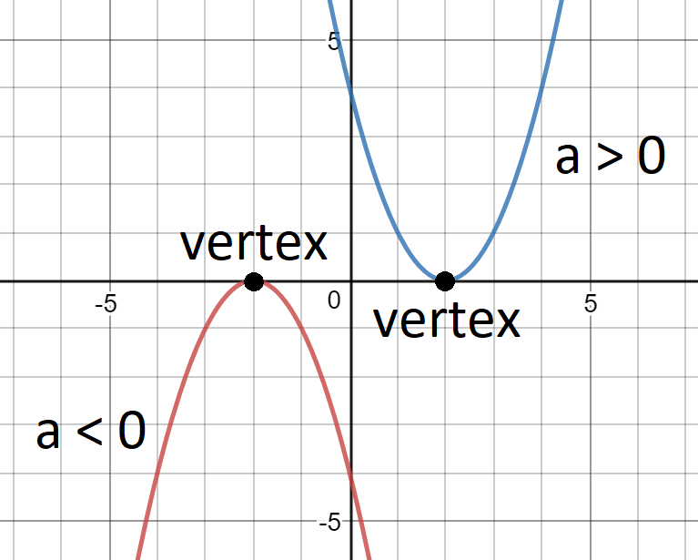

The vertex can be located using the following formula:

**Vertex Formula**: The vertex of a parabola occurs at the *x*-coordinate,



Once you calculate the *x*-coordinate, you can substitute that value for *x* in the quadratic equation to solve for *y*.

The last details of the graph we may be interested in are the *x* and *y* intercepts. We can solve for these as we did in section 4.1, however notice that we will need to use the quadratic formula to solve for the *x*-intercepts.

To summarize, if we want to graph a parabola, we need to determine the following characteristics of the equation:

1. What is the orientation of the parabola (opening up or down)?
2. Where is the vertex located?
3. Where are the *x-* and *y-*intercepts located?

Guided Example 3 Practice

|  |  |
| --- | --- |
| Sketch a graph of the equation  by finding the vertex and the *x-* and *y-*intercepts. Use these points to graph the parabola.  **Solution** Notice in this equation that , , and . Since *a* is positive we know the parabola opens upwards.  Next, we find *x*-coordinate of the vertex using  :    Substitute this value into the equation  to find the corresponding *y*-coordinate:    This makes the vertex  Next, we find the *x*-intercepts by setting *y* to zero,    and solving for *x* using the quadratic formula:  Set , , and .  Simplify under the root    Carry out the square root to give . Using the plus and minus signs separately gives two solutions:  and  The x-intercepts are (5, 0) and (-1, 0).  Lastly, we find the *y*-intercept by setting *x* to zero in and solving for *y*:    The y-intercept is (0, -5).  Now that we have calculated all of the details, we will plot the points on the graph and sketch a smooth curve to connect them: | Sketch a graph of the equation  by finding the vertex and the *x-* and *y*-intercepts. Use these points to graph the parabola. |

Guided Example 4 Practice

|  |  |
| --- | --- |
| Sketch a graph of the equation  by finding the vertex and the *x-* and *y*-intercepts. Use these points to graph the parabola  **Solution** Notice in this equation , , and . Since *a* is negative we know the parabola opens downwards. Find *x*-coordinate of the vertex using :    Substitute this value into the equation  to find the *y*-coordinate:    Putting these values together places the vertex at .  Next, we find the *x*-intercepts by setting *y* to zero, , and solving for *x* using the quadratic formula :    Find each of the solutions:  and  The x-intercepts are (given as decimals to make graphing easier):.  Lastly, we find the *y*-intercept by setting *x* to zero in  and solving for *y*:    The y-intercept is .  Now that we have calculated all of the details, we will plot the points on the graph and sketch a smooth curve to connect them: | Sketch a graph of the equation  by finding the vertex and the *x-* and *y*-intercepts. Use these points to graph the parabola |

## How can you model data with a quadratic equation?

Key Terms

Summary

Consider a parabola that opens down (a < 0): It begins by increasing rapidly, but the rate of increase slows until it reaches its maximum value (vertex). After the vertex it, begins decreasing, slowly at first, but the rate of decrease continues to speed up. Any phenomena that exhibits similar behavior is a good candidate to be modeled with a quadratic equation. For example, a cannon ball shot up into the air will rapidly increase in height, then slow down and reach a maximum height, and then start to fall faster and faster back to the ground. A parabola that opens upwards (a > 0) exhibits similar behavior in which it decreases to a minimum value (vertex) and then starts to increase again.

When using quadratic models, often we are interested in the maximum or minimum value of the model, which would require finding the vertex using . We may also want to know when the quantity we are measuring reaches a specific value. This requires the quadratic formula,  . Below we investigate some of these cases.

Notes

Guided Example 5 Practice

|  |  |
| --- | --- |
| A cannonball is fired directly upward with an initial velocity of 500 feet per second. Its height above the ground at time *t* can be modeled with the equation . How high does the cannonball travel before it begins to fall back to the ground?  **Solution** We are asked to find the maximum height that the cannonball travels, and since our parabola opens downwards (*a* is negative) we must find the vertex. Notice in our equation . Using the vertex formula , we have:    The cannonball reaches its maximum height after 15.625 seconds. To find the height at 15.625 seconds, we will substitute this time into the equation  and solve for *h*:    The maximum height that the cannonball will reach before travelling back to the ground is 3,906.25 feet. | Assume the equation  models the sales of a recently released video game where *x* is the number of weeks after release, and *S* is the number of sales in millions. According to this model, what are the peak sales for the game? |

Guided Example 6 Practice

|  |  |
| --- | --- |
| Suppose a company’s stock is priced at $250 per share before the CEO makes an unpopular comment in an interview that results in a drop in the value of the stock. After some time passes, the stock starts to rise again. Financial analysts model the stock’s behavior with the equation , where *x* is the number of months after the interview, and *y* is the price of the stock. How many months will it take for the stock to return to its value before the unpopular comment was made?  **Solution** Notice before the interview we are told the stock was valued at $250 per share, so we are being asked to find the number of months (*x*) until the stock reaches $250 per share again. We will substitute 250 into the equation for *y* and solve for *x*. This will require the quadratic formula  , but first we must set the equation equal to zero:    Subtract 250 from each side.    Apply the quadratic formula equation using , , and :    Simplify within the square root  Take the square root  Work out each solution  The solution  represents the fact that before the interview (zero months after it occurred) the price of the stock was $250. The solution we want is (rounded), which means about 3.9 months after the interview, the stock returns to $250 per share. | A video goes viral on social media, and the number of views per day can be modeled with the equation , where *x* is the number of days after the video is posted, and *y* is the number of views per day in thousands. According to the model, after how many days do people stop watching the video? |

# Section 4.4 Exponential Equations and Growth

* What is the difference between linear, quadratic, and exponential growth?
* How can exponential equations model growth?
* How are exponential equations solved using logarithms?

## What is the difference between linear, quadratic, and exponential growth?

Key Terms

Compound Growth Compound Interest

Summary

Exponential growth involves **compound growth**, that is, growth on top of previous growth. For example, if you invest $1,000 in an account that earns 10% interest compounded annually, in the first year you would earn 10% of $1,000, which is $100. Now you have $1,100 in the account. In the second year, you would earn 10% of $1,100, which is $110, so now you have $1,210 in the account. Notice each year you are earning interest on the original $1,000 *plus the previous interest you have already accumulated*. This is known as **compound interest**.

This same principal can be applied to population growth, and many other scenarios. Because the growth rate is applied repeatedly for each time unit, we can simplify the calculation by using exponents, which is why we use the term exponential growth.

Let us summarize our three types of growth:

* **Linear growth**: a quantity changes by the same *constant amount* for each unit of time.
* **Exponential growth**: a quantity changes by the same *percentage or factor* for each unit of time.
* **Quadratic growth**: a quantity *increases, reaches a maximum, then decreases* or *decreases, reaches a minimum, then increases*.

Notes

Guided Example 1 Practice

|  |  |
| --- | --- |
| Determine which of the scenarios should be modeled with a linear, quadratic, or exponential equation:   * 1. A pond is stocked with 200 adult bass, and the amount of bass increases by 15% each year.   **Solution** This scenario can be modeled with an exponential equation because the population increases by a percent each year. For example, in the first year there would be  new bass, bringing the total to 230. In the next year there would be  new bass bringing the total to 264.5 bass, and so on. This illustrates an example of compound growth.   * 1. In 2015 there were 4.7 million households without cable TV, and that number was increasing by 100,000 per year.   **Solution** This scenario can be modeled with a linear equation because the quantity increases by the same constant amount each year. We can express 100,000 as 0.1 million and model the scenario with the equation , where *x* is the number of years after 2015, and *y* is the number of households without cable tv in millions.   * 1. A new business experiences negative profit (cumulative profit decreases) while it establishes a customer base and increases its revenue. Eventually the cumulative profit reaches a minimum negative value and begins to increase towards positive values.   **Solution** This scenario can be modeled with a quadratic equation because it describes the behavior of a parabola that opens upwards. The cumulative profit begins by decreasing, then reaches a minimum value (vertex), and then begins to increase. | Determine which of the scenarios should be modeled with a linear, quadratic, or exponential equation:   * 1. In the year 2009 there were 432 cases of violent crime per 100,000 people in the US, and this number was decreasing by 26 per year.   2. A post on social media goes viral and the number of likes per day increases rapidly. After a few days the popularity levels off and the number of likes per day starts to fall.   3. The average 4-door sedan costs $21,000 today, and due to inflation that cost would increase by 2.1% each year. |

## How can exponential equations model growth?

Key Terms

Exponential Growth Model

Summary

A common form of **Exponential Growth Model** is the following:



* *P* is the initial value
* *r* is the growth rate (usually expressed as a percent)
* *t* is the amount of time (usually in years)
* *F* is the future value, that is, the total amount after *t* time units have passed

Consider the previous example of investing $1,000 in an account earning 10% interest compounded annually. How much money would you have in the account after 5 years? We could compute this using :



After 5 years you would have $1,610.51 in the account.

Notice the exponential growth model has four variables in it. We could be given any of the three variables and be asked to find the fourth. Below we will investigate cases solving for *F*, *P*, and *r*.

Notes

Guided Example 2 Practice

|  |  |
| --- | --- |
| In 2015 the US population was 321 million and was growing at a rate of 0.8% each year. Use this information to create an exponential model and estimate the US population in the year 2030.  **Solution** We are given an initial population, a growth rate, and an amount of time, and we are asked to find the future value. We can summarize this information in the following way:  Given *P* = 321, *r* = 0.008, and *t* = 15 (2030-2015), find *F*. Substitute these values into the exponential growth model and solve for *F*:      According to our model, in the year 2030 the US population should reach about 362 million people. | In 2015 the population of Japan was 127 million and had a growth rate of -0.1% each year. Use this information to create an exponential model and estimate the population of Japan in the year 2030. |

Guided Example 3 Practice

|  |  |
| --- | --- |
| How much should be invested in a savings account earning 5% interest compounded annually, if you want to have $10,000 after 6 years?  **Solution** We are given an interest rate, and an amount of time, and a future value, and we are asked to find the initial investment needed to attain that future value. We can summarize this information in the following way:  Given *r* = 0.05, *F* = 10,000, and *t* = 6, find *P*. We will substitute these values into the exponential growth model  and solve for *P*:  Put in the values  Divide both sides by  Simplify the expression      You would need to invest about $7,462.15 in order to have $10,000 in 6 years.  One thing to note here is that if we rounded down to get 7462.15, we would have only $9,999.99 after 6 years Often calculations where we find present values should automatically be rounded up. So, a better answer would be $7,462.16. | A population of trout were seeded into a lake and increased by 60% per year. After 4 years there were 1500 trout in the lake. Use this information to create an exponential model and find the size of the initial population that was introduced to the lake. |

Guided Example 4 Practice

|  |  |
| --- | --- |
| A bacteria culture of 200 bacteria is started in a petri dish. After 4 hours the population has grown to 500 bacteria. Use this information to create an exponential model and estimate the growth rate of the bacteria culture.  **Solution** We are given an initial population, an amount of time, and a future value, and asked to find the growth rate. We can summarize this information in the following way:  Given *P* = 200, *F* = 500, and *t* = 4, find *r*. Substitute these values into the exponential growth model and solve for *r*:    Put in values  Divide both sides by 200  Simplify  Undo the power with a fourth root.  Subtract 1 to isolate r  Compute the root on your calculator  Note that the  command is found in the MATH menu on a graphing calculator.    This root may also be thought of as a ¼ power and evaluate with the ^ button.    Since *r* is a growth rate, we write our final answer as a percent: . So according to our model, the population of bacteria increased by about 25.7% each hour. | Suppose your parents placed $5,000 in a college savings account when you were born, and when you turned 18 the account had grown to $22,000. Assuming the interest was compounded annually, what was the interest rate on the account? |

## How are exponential equations solved using logarithms?

Key Terms

Logarithm Common Logarithm

Exponent Property of Logarithms

Summary

We have yet to solve an exponential model for time, *t*. Because *t* is in the exponent position, it requires the use of a special algebraic function called a logarithm. A **logarithm** is the inverse of an exponential. For example, given the exponential equation , we could rewrite it as a logarithmic equation in the following form: . That is,represents the power that we raise 2 to, in order to get 8. We can think of this relationship as an input/output relationship to make this easier to understand.

Input is 3

Output is 8



Base is 2

Thinking this way, we say that the input to the base is 3 giving an output of 8. A logarithm reverses the role of the input and output. Now the base on the logarithm is 2. The input to the logarithm is 8 and the output is 3.

Output is 3

Input is 8



Base is 2

You can use your calculator to verify this relationship by selecting the MATH button and then scrolling down to the LogBASE option.

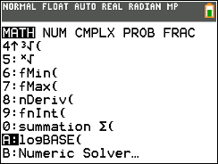 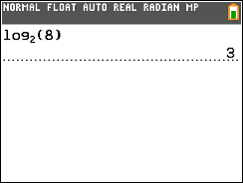

We will often use a common logarithm, which is a base 10 logarithm, and is abbreviated as “log.”

**Common Logarithm:**



There is a lot to say about logarithms, but we are going to use them in a very specific way that requires the following property:

**Exponent Property of Logarithms:**



This property will allow us to extract a value from the exponent position. For example, consider the equation . We know that  and that , so the power we raise 2 to in order to get 7 must be between 2 and 3. To get a more exact result, we will apply a logarithm and use the exponent property:



Apply logs to each side of the equation

Apply the exponent property of logarithms

Divide both sides by 

Use a calculator to approximate to three decimal places

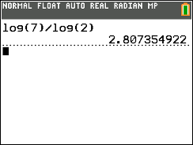

Notice  which is approximately 7.

Notice that we could have solved by converting it to a logarithm directly. In this case we would get . This value is exactly the same as .



This relationship comes in handy if your calculator does not have a logBASE command. When this happens, we can use the relationship



to calculate the logarithm using the log button on the calculator.

Below we will apply these methods to exponential models to solve for *t*.

Notes

Guided Example 5 Practice

|  |  |
| --- | --- |
| If $4500 is placed into an account earning 4.3% interest compounded annually, how long will it take for the amount in the account to double?  **Solution** If we want to double our initial amount of $4,500, then that means we are seeking a future amount of $9,000. We can summarize this information in the following way: Given *P* = 4500, *r* = 0.043, and *F* = 9000, find *t*. Substitute these values into the exponential growth model and solve for *t*:    Divide both sides by 4500  Take the log of both sides  Use the exponential property of logs  Divide both sides by  Evaluate the log on a calculator    It would take approximately 16.5 years for our initial investment of $4,500 to double to $9,000.  We can also solve the equation by converting directly to a logarithm.    Convert to a logarithm  Divide both sides by 4500 | If you invest $2,500 in an account earning 5.4% compounded annually, and you want to save $20,000 dollars for a down payment on a house, how long must you wait until you have that down payment? |

Guided Example 6 Practice

|  |  |
| --- | --- |
| In 2015 the US population was 321 million and was growing at a rate of 0.8% each year. In what year will the population reach 400 million?  **Solution** We are given an initial population, a growth rate, and a future population, and we must solve for time. We can summarize this information in the following way: Given *P* = 321, *r* = 0.008, and *F* = 400, find *t*. Substitute these values into the exponential growth model and solve for *t*:    Divide both sides by 321  Apply log to both sides  Apply the exponent property of logs  Divide both sides by  Evaluate logs on a calculator    We can also convert to a logarithm as shown below.    Convert to a logarithm  Divide both sides by 321    According to our model it the US population will reach 400 million people in approximately 28 years after 2015, or by the year 2043. | In 2015 the population of India was 1.225 billion and was growing at a rate of 1.2% each year. In what year will the population double? |

**Chapter 4 Solutions**

Section 4.1

1. 
2. 
3. Intercepts at (-5,0) and (0, 6)

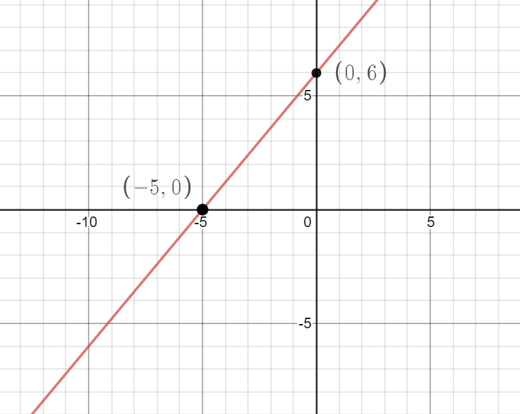

1. The *y* intercept is at (0, 2000) and says that there is 2000 gallons initially. The *x* intercept is at (4, 0) and means that it takes 4 hours for the pool to have nothing in it.

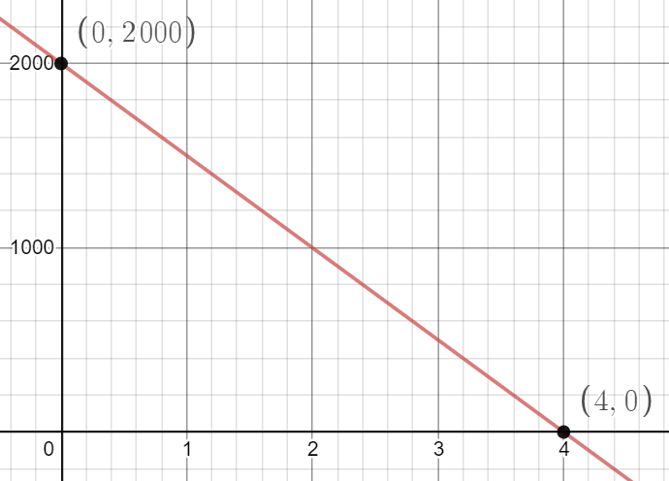

Section 4.2

1. 
2. The model is where *x* is the number of years after 2016 and *y* is the average student loan debt per borrower. The debt reaches $50,000 in the year 2018.
3. 
4. The model is  where *x* is the number of years after 2010 and *y* is the number of computer programming jobs in thousands. The number of jobs reaches 500,000 in 2025.

Section 4.3

1. 
2. 

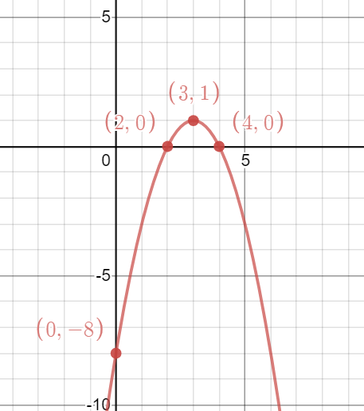

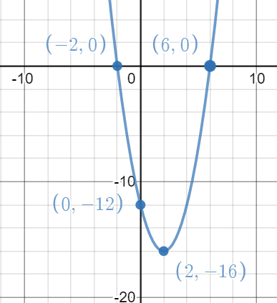

1. Peak sales are 14 million on Week 2
2. 14 days

Section 4.4

1. a. linear, b. quadratic, c. exponential
2.  . At , million.
3.  means the initial population is about 229.
4. Approximately 8.58%
5. Approximately 39.5 years
6. In approximately 58.1 years in the year 2073